# Digital Control: Exercise 5

Xu Fei feixu12@student.hh.se

## Basic theory

1. **Tank dynamics**

A tank process is there animated and can be controlled manually or by feedback control. The dynamics of the process can be described by the mass balance equation:

$$A\frac{dh}{dt}=q_{in}-q_{out}$$

Where $A$ is the tank area, $h$ is the height of water, $q_{in}$ and $q_{out}$ are the inflow and outflow of water, respectively. Energy balance (Bernoulli) gives:

$$ρgh=\frac{ρv^{2}}{2}⇒v=\sqrt{2gh}$$

Where $v$ is the outlet water velocity. With outlet area $a$, the outflow then becomes:

$$q_{out}=av=a\sqrt{2gh}$$

The pump flow is proportional to the pump voltage $V$, according to:

$$q_{in}=kV$$

The nonlinear tank dynamics are therefore:

$$A\frac{dh}{dt}=kV-a\sqrt{2gh} →\frac{dh}{dt}=-α\sqrt{h}+βV=f(h,V)$$

Where $α=\frac{α\sqrt{g}}{A}$ and $β=\frac{k}{A}$. For simplicity, the values are chosen $α=β=1$ and when the valve is opened $α=4$.

1. **Linearization**

Balance level $\dot{(h}=0)$ for a constant pump voltage $v_{0}$ corresponds to the level $h_{0}={v_{0}}^{2}$. Linearization around the balance level gives:

$$\frac{d∆h}{dt}=f\left(h,V\right)≈\frac{df}{dh}\left(h_{0},V_{0}\right)∆h+\frac{df}{dV}\left(h_{0},V_{0}\right)∆V$$

Where with notation $y=∆h=h-h_{0}$ and $u=∆V=V-V_{0}$

$$\frac{dy}{dt}=py+du, \left\{\begin{aligned}p=-\frac{α}{2\sqrt{h_{0}}} \\ d=1\end{aligned}\right.$$

1. **Sampling**

­­Zero-order-hold sampling with sampling period $h_{s} = 1$ gives

$$y\left(k\right)=λy\left(k-1\right)+bu\left(k-1\right), \left\{\begin{aligned}λ=e^{ph_{s}}=e^{p} \\ b=(λ-1)/p\end{aligned}\right.$$

In polynomial form $A\left(q^{-1}\right)=1-λq^{-1}$ and $B\left(q^{-1}\right)=bq^{-1}$.

1. **Identification**

The parameters $λ$ and $b$ can be estimated experimentally by the least-squares method. This is performed as follows: Excite the system around the balance level $h_{0}$, collect input and output data.

## Tank models at different operating points

Now do the following experiment with the tank process. To access the samples, first write in the command window

> global samples

The variable samples will now continuously change with the data from the simulation. It contains 100 of the latest data samples, as $samples=[t, u, y]$, where is the time (in seconds), $u$ the input samples and $y$ the output samples (height level $h$).

1. Excite the tank system manually using $u_{0}(K=0)$ such that $y$ varies with mean close to $h_{0}= 20$.

As we already know from part1,

$$\left\{\begin{aligned}p=-\frac{α}{2\sqrt{h_{0}}}=-\frac{1}{2\sqrt{20}}=-\frac{\sqrt{5}}{20} \\ d=1\end{aligned}\right.$$

Zero-order-hold sampling with sampling period $h_{s} = 1$ gives

$$y\left(k\right)=λy\left(k-1\right)+bu\left(k-1\right), \left\{\begin{aligned}λ=e^{ph_{s}}=e^{p}=e^{-\frac{\sqrt{5}}{20}}≈0.8942 \\ b=\frac{λ-1}{p}=\frac{e^{-\frac{\sqrt{5}}{20}}-1}{-\frac{\sqrt{5}}{20}}≈0.9461\end{aligned}\right.$$

Then I manually set $u_{0}(K=0)$ in P-control mode to make the $y$ varies with mean close to $h_{0}= 20$. I got the samples as following table:

Table 2.1 Samples when $h_{0}= 20$

|  |  |  |  |
| --- | --- | --- | --- |
| 21587.7574 | 4.3698 | 19.8371 | 20 |
| 21588.7779 | 4.3698 | 19.7561 | 20 |
| 21589.798 | 4.3698 | 19.6838 | 20 |
| 21590.8787 | 4.3698 | 19.6159 | 20 |
| 21591.9987 | 4.3698 | 19.5537 | 20 |
| 21593.018 | 4.3698 | 19.5035 | 20 |
| 21594.0379 | 4.3698 | 19.4588 | 20 |
| 21595.1378 | 4.3698 | 19.416 | 20 |
| 21596.1782 | 4.3698 | 19.3802 | 20 |
| 21597.2176 | 4.3698 | 19.3484 | 20 |
| 21598.2578 | 4.3698 | 19.3201 | 20 |
| 21599.259 | 4.3698 | 19.2959 | 20 |
| 21600.3392 | 4.3698 | 19.2726 | 20 |
| 21601.3987 | 4.3698 | 19.2525 | 20 |
| 21602.4792 | 4.3698 | 19.2342 | 20 |
| 21603.5392 | 4.3698 | 19.2184 | 20 |
| 21604.5987 | 4.3698 | 19.2044 | 20 |
| 21605.6386 | 4.3698 | 19.1922 | 20 |
| 21606.6588 | 4.3698 | 19.1816 | 20 |
| 21607.6837 | 4.3698 | 19.1721 | 20 |
| 21608.6993 | 4.3698 | 19.1637 | 20 |
| 21609.7797 | 4.3698 | 19.1558 | 20 |
| 21610.8001 | 4.3698 | 19.1492 | 20 |
| 21611.84 | 4.3698 | 19.1431 | 20 |
| 21612.9 | 4.3698 | 19.1377 | 20 |
| 21614.0196 | 4.3698 | 19.1327 | 20 |
| 21615.1196 | 4.3698 | 19.1283 | 20 |
| 21616.1205 | 4.3698 | 19.1247 | 20 |
| 21617.1599 | 4.3698 | 19.1215 | 20 |
| 21618.1605 | 4.3698 | 19.1187 | 20 |
| 21619.241 | 4.3698 | 19.116 | 20 |
| 21620.3408 | 4.3698 | 19.1136 | 20 |
| 21621.4411 | 5.0703 | 19.1114 | 20 |
| 21622.461 | 4.691 | 19.7842 | 20 |
| 21623.4611 | 4.691 | 20.0141 | 20 |
| 21624.5411 | 4.3755 | 20.2352 | 20 |
| 21625.6409 | 4.557 | 20.108 | 20 |
| 21626.7016 | 4.557 | 20.1809 | 20 |
| 21627.7217 | 4.557 | 20.2433 | 20 |
| 21628.7613 | 4.557 | 20.3 | 20 |
| 21629.7827 | 4.557 | 20.3497 | 20 |
| 21630.8822 | 4.557 | 20.3972 | 20 |
| 21631.9216 | 4.557 | 20.4372 | 20 |
| 21632.9622 | 4.557 | 20.4728 | 20 |
| 21633.9627 | 4.557 | 20.5034 | 20 |
| 21634.9822 | 4.557 | 20.5313 | 20 |
| 21636.0227 | 4.557 | 20.5567 | 20 |
| 21637.0827 | 4.557 | 20.5798 | 20 |
| 21638.1426 | 4.557 | 20.6003 | 20 |
| 21639.2226 | 4.557 | 20.6189 | 20 |
| 21640.2426 | 4.557 | 20.6345 | 20 |
| 21641.2431 | 4.557 | 20.6482 | 20 |
| 21642.2826 | 4.557 | 20.661 | 20 |
| 21643.283 | 4.557 | 20.672 | 20 |
| 21644.383 | 4.557 | 20.6827 | 20 |
| 21645.4625 | 4.557 | 20.692 | 20 |
| 21646.4625 | 4.557 | 20.6998 | 20 |
| 21647.563 | 4.557 | 20.7073 | 20 |
| 21648.6626 | 4.557 | 20.714 | 20 |
| 21649.744 | 4.557 | 20.7199 | 20 |
| 21650.7841 | 4.557 | 20.7249 | 20 |
| 21651.8835 | 4.557 | 20.7296 | 20 |
| 21652.884 | 4.557 | 20.7334 | 20 |
| 21653.9836 | 4.557 | 20.7372 | 20 |
| 21655.0046 | 4.557 | 20.7403 | 20 |
| 21656.0243 | 4.557 | 20.743 | 20 |
| 21657.1443 | 4.557 | 20.7457 | 20 |
| 21658.2638 | 4.557 | 20.7481 | 20 |
| 21659.3048 | 4.557 | 20.7501 | 20 |
| 21660.3451 | 4.557 | 20.7518 | 20 |
| 21661.4047 | 4.557 | 20.7534 | 20 |
| 21662.4849 | 4.557 | 20.7548 | 20 |
| 21663.5645 | 4.557 | 20.7561 | 20 |
| 21664.5646 | 4.557 | 20.7572 | 20 |
| 21665.565 | 4.557 | 20.7581 | 20 |
| 21666.5848 | 4.557 | 20.759 | 20 |
| 21667.625 | 4.557 | 20.7598 | 20 |
| 21668.725 | 4.557 | 20.7605 | 20 |
| 21669.7861 | 4.557 | 20.7612 | 20 |
| 21670.8258 | 4.557 | 20.7617 | 20 |
| 21671.8664 | 4.557 | 20.7622 | 20 |
| 21672.9664 | 4.272 | 20.7627 | 20 |
| 21674.0862 | 4.272 | 20.4628 | 20 |
| 21675.206 | 4.272 | 20.1979 | 20 |
| 21676.2062 | 4.4535 | 19.9876 | 20 |
| 21677.2264 | 4.4535 | 19.971 | 20 |
| 21678.3463 | 4.4535 | 19.9548 | 20 |
| 21679.4074 | 4.4535 | 19.9412 | 20 |
| 21680.5069 | 4.4535 | 19.9287 | 20 |
| 21681.6066 | 4.4535 | 19.9177 | 20 |
| 21682.707 | 4.4535 | 19.908 | 20 |
| 21683.7071 | 4.4535 | 19.9001 | 20 |
| 21684.787 | 4.4535 | 19.8925 | 20 |
| 21685.8076 | 4.4535 | 19.8861 | 20 |
| 21686.9264 | 4.4535 | 19.8799 | 20 |
| 21687.987 | 4.4535 | 19.8748 | 20 |
| 21688.9875 | 4.4535 | 19.8704 | 20 |
| 21690.008 | 4.4535 | 19.8664 | 20 |
| 21691.108 | 4.4535 | 19.8626 | 20 |
| 21692.1275 | 4.4535 | 19.8595 | 20 |

And I use these data to calculate $θ$, then we can get:

$$θ=\left({λ \atop b}\right)=\left({0.89 \atop 0.9822}\right)≈\left({0.8942 \atop 0.9461}\right)(theory value)$$

From the result, we can found it’s quite close to the theory value.

1. Calculate the response of your estimated model and compare it to the real response.

The result is shown in figure 2.1.

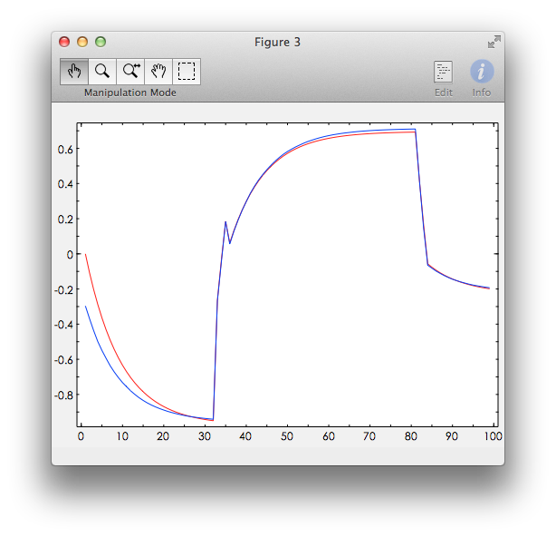

Figure 2.1 Comparison between the responses of estimated model and real model

In the figure, the red curve is the response of estimated model and the blue curve is the response of real model, we can see, at first these two curves have a bigger error, and then they got almost the same, the error is very small.

1. Repeat the above experiment with excitation around $h_{0}= 350$.

$$\left\{\begin{aligned}p=-\frac{α}{2\sqrt{h_{0}}}=-\frac{1}{2\sqrt{350}}=-\frac{\sqrt{14}}{140}≈-0.0267 \\ d=1\end{aligned}\right.$$

$$y\left(k\right)=λy\left(k-1\right)+bu\left(k-1\right), \left\{\begin{aligned}λ=e^{ph_{s}}=e^{p}=e^{-\frac{\sqrt{14}}{140}}≈0.9737 \\ b=\frac{λ-1}{p}=\frac{e^{-\frac{\sqrt{14}}{140}}-1}{-\frac{\sqrt{14}}{140}}≈0.9868\end{aligned}\right.$$

Then I manually set $u_{0}(K=0)$ in P-control mode to make the $y$ varies with mean close to $h_{0}= 350$. I got the samples as following table:

Table 2.2 Samples when $h_{0}= 350$

|  |  |  |  |
| --- | --- | --- | --- |
| 22412.5586 | 18.828 | 347.5852 | 350 |
| 22413.6787 | 18.828 | 347.7887 | 350 |
| 22414.7986 | 18.828 | 347.9861 | 350 |
| 22415.8386 | 18.828 | 348.1643 | 350 |
| 22416.9386 | 18.828 | 348.3473 | 350 |
| 22417.9583 | 18.828 | 348.5123 | 350 |
| 22418.9586 | 18.828 | 348.6698 | 350 |
| 22419.9596 | 18.828 | 348.8232 | 350 |
| 22420.9996 | 18.828 | 348.9783 | 350 |
| 22422.0395 | 18.828 | 349.1291 | 350 |
| 22423.0593 | 18.828 | 349.273 | 350 |
| 22424.1589 | 18.828 | 349.4239 | 350 |
| 22425.1592 | 19.119 | 349.5573 | 350 |
| 22426.1792 | 18.6172 | 349.9825 | 350 |
| 22427.1992 | 18.6172 | 349.8912 | 350 |
| 22428.2991 | 18.6172 | 349.7956 | 350 |
| 22429.4001 | 18.6172 | 349.7027 | 350 |
| 22430.5002 | 18.6172 | 349.6125 | 350 |
| 22431.5199 | 18.6172 | 349.5312 | 350 |
| 22432.6201 | 18.6172 | 349.446 | 350 |
| 22433.6201 | 18.6172 | 349.3707 | 350 |
| 22434.7012 | 18.6172 | 349.2915 | 350 |
| 22435.8012 | 18.6172 | 349.2133 | 350 |
| 22436.9012 | 18.6172 | 349.1373 | 350 |
| 22437.9211 | 18.6172 | 349.0688 | 350 |
| 22439.0405 | 18.6172 | 348.9957 | 350 |
| 22440.0807 | 18.6172 | 348.9298 | 350 |
| 22441.081 | 18.6172 | 348.8681 | 350 |
| 22442.1807 | 18.6172 | 348.8022 | 350 |
| 22443.2009 | 18.6172 | 348.7427 | 350 |
| 22444.221 | 18.6172 | 348.6848 | 350 |
| 22445.3212 | 18.6172 | 348.6242 | 350 |
| 22446.4414 | 18.6172 | 348.5642 | 350 |
| 22447.4812 | 18.6172 | 348.5101 | 350 |
| 22448.4812 | 18.6172 | 348.4595 | 350 |
| 22449.5621 | 18.6172 | 348.4064 | 350 |
| 22450.5621 | 18.6172 | 348.3585 | 350 |
| 22451.6615 | 18.6172 | 348.3074 | 350 |
| 22452.7415 | 18.6172 | 348.2586 | 350 |
| 22453.7814 | 18.6172 | 348.2129 | 350 |
| 22454.7822 | 18.6172 | 348.1701 | 350 |
| 22455.8821 | 18.6172 | 348.1244 | 350 |
| 22456.9819 | 18.6172 | 348.08 | 350 |
| 22458.0622 | 18.6172 | 348.0377 | 350 |
| 22459.1026 | 18.6172 | 347.9981 | 350 |
| 22460.1228 | 18.6172 | 347.9603 | 350 |
| 22461.2063 | 18.6172 | 347.9213 | 350 |
| 22462.2832 | 18.6172 | 347.8836 | 350 |
| 22463.3029 | 18.6172 | 347.8489 | 350 |
| 22464.3836 | 18.6172 | 347.8131 | 350 |
| 22465.3837 | 18.6172 | 347.781 | 350 |
| 22466.3837 | 18.6172 | 347.7497 | 350 |
| 22467.5033 | 19.3085 | 347.7156 | 350 |
| 22468.5224 | 18.819 | 348.3804 | 350 |
| 22469.6237 | 18.819 | 348.5476 | 350 |
| 22470.6244 | 18.819 | 348.6953 | 350 |
| 22471.6444 | 18.819 | 348.8419 | 350 |
| 22472.6644 | 18.819 | 348.9845 | 350 |
| 22473.7245 | 18.819 | 349.1286 | 350 |
| 22474.8056 | 18.819 | 349.2714 | 350 |
| 22475.8255 | 18.819 | 349.4024 | 350 |
| 22476.9257 | 18.819 | 349.5398 | 350 |
| 22477.9846 | 18.819 | 349.6683 | 350 |
| 22479.0253 | 18.819 | 349.791 | 350 |
| 22480.1052 | 18.819 | 349.9148 | 350 |
| 22481.1055 | 18.819 | 350.0264 | 350 |
| 22482.1254 | 18.819 | 350.1371 | 350 |
| 22483.2055 | 18.819 | 350.2511 | 350 |
| 22484.2455 | 18.819 | 350.3578 | 350 |
| 22485.2458 | 18.819 | 350.4576 | 350 |
| 22486.2655 | 18.819 | 350.5567 | 350 |
| 22487.3665 | 18.819 | 350.6607 | 350 |
| 22488.4064 | 18.819 | 350.7562 | 350 |
| 22489.4065 | 18.819 | 350.8455 | 350 |
| 22490.4257 | 18.819 | 350.9342 | 350 |
| 22491.5257 | 18.819 | 351.0272 | 350 |
| 22492.5465 | 18.819 | 351.1111 | 350 |
| 22493.5662 | 18.819 | 351.1926 | 350 |
| 22494.6061 | 18.8935 | 351.2735 | 350 |
| 22495.6857 | 18.8935 | 351.4344 | 350 |
| 22496.7261 | 18.6047 | 351.5851 | 350 |
| 22497.7262 | 18.6047 | 351.4411 | 350 |
| 22498.7461 | 18.6047 | 351.2982 | 350 |
| 22499.787 | 18.6047 | 351.1564 | 350 |
| 22500.8866 | 18.6047 | 351.0107 | 350 |
| 22501.9264 | 18.6047 | 350.8768 | 350 |
| 22503.027 | 18.6047 | 350.7391 | 350 |
| 22504.128 | 18.6047 | 350.6054 | 350 |
| 22505.128 | 18.6047 | 350.4872 | 350 |
| 22506.1878 | 18.6047 | 350.3654 | 350 |
| 22507.1879 | 18.6047 | 350.2536 | 350 |
| 22508.1879 | 18.6047 | 350.1448 | 350 |
| 22509.1882 | 18.6047 | 350.0388 | 350 |
| 22510.3017 | 18.6047 | 349.924 | 350 |
| 22511.3083 | 18.6047 | 349.8232 | 350 |
| 22512.4077 | 18.6047 | 349.7161 | 350 |
| 22513.4079 | 18.6047 | 349.6214 | 350 |
| 22514.428 | 18.6047 | 349.5274 | 350 |
| 22515.4681 | 18.6047 | 349.4342 | 350 |
| 22516.4682 | 18.6047 | 349.3469 | 350 |

And I use these data to calculate $θ$, then we can get:

$$θ=\left({λ \atop b}\right)=\left({0.9725 \atop 1.0244}\right)≈\left({0.9737 \atop 0.9868}\right)(theory value)$$

Calculate the response of your estimated model and compare it to the real response. The result is shown in figure 2.2.

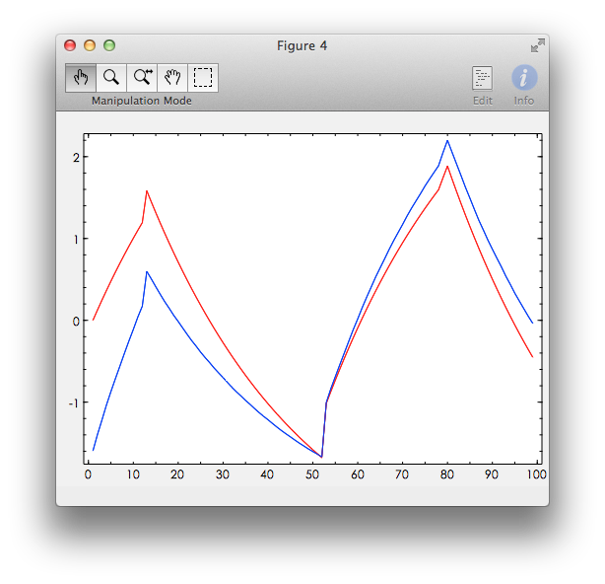

Figure 2.2 Comparison between the responses of estimated model and real model

## Changed model when opening the valve

Click on the valve to opening it. Then the outflow is increased and $α = 4$. Estimate how the model is changed by repeating Problem 1a) and b), now with the valve fully opened.

$$\left\{\begin{aligned}p=-\frac{α}{2\sqrt{h_{0}}}=-\frac{4}{2\sqrt{20}}=-\frac{\sqrt{5}}{5} \\ d=1\end{aligned}\right.$$

$$y\left(k\right)=λy\left(k-1\right)+bu\left(k-1\right), \left\{\begin{aligned}λ=e^{ph_{s}}=e^{p}=e^{-\frac{\sqrt{5}}{5}}≈0.6394 \\ b=\frac{λ-1}{p}=\frac{-\frac{\sqrt{5}}{5}-1}{-\frac{\sqrt{5}}{5}}≈0.8063\end{aligned}\right.$$

Then I manually set $u_{0}(K=0)$ in P-control mode to make the $y$ varies with mean close to $h_{0}= 20$ and also open the valve. I got the samples as following table:

Table 3.1 Samples when $h_{0}= 20$ and $α=4$

|  |  |  |  |
| --- | --- | --- | --- |
| 23856.6389 | 17.7375 | 19.6637 | 20 |
| 23857.679 | 17.7375 | 19.6637 | 20 |
| 23858.7789 | 17.7375 | 19.6637 | 20 |
| 23859.7796 | 17.7375 | 19.6637 | 20 |
| 23860.88 | 17.7375 | 19.6637 | 20 |
| 23862.0001 | 17.7375 | 19.6637 | 20 |
| 23863.0599 | 17.7375 | 19.6637 | 20 |
| 23864.1 | 17.7375 | 19.6637 | 20 |
| 23865.22 | 17.7375 | 19.6637 | 20 |
| 23866.3 | 17.7375 | 19.6637 | 20 |
| 23867.36 | 17.7375 | 19.6637 | 20 |
| 23868.4001 | 17.7375 | 19.6637 | 20 |
| 23869.4219 | 17.7375 | 19.6637 | 20 |
| 23870.4616 | 17.7375 | 19.6637 | 20 |
| 23871.5806 | 17.7375 | 19.6637 | 20 |
| 23872.6813 | 17.7375 | 19.6637 | 20 |
| 23873.6817 | 17.7375 | 19.6637 | 20 |
| 23874.7009 | 17.8277 | 19.6637 | 20 |
| 23875.7009 | 17.8277 | 19.7363 | 20 |
| 23876.7409 | 17.8277 | 19.784 | 20 |
| 23877.761 | 17.539 | 19.8135 | 20 |
| 23878.841 | 17.539 | 19.5861 | 20 |
| 23879.8419 | 17.539 | 19.4545 | 20 |
| 23880.8819 | 16.9357 | 19.3684 | 20 |
| 23881.9619 | 16.9357 | 18.7988 | 20 |
| 23882.9706 | 17.2379 | 18.4705 | 20 |
| 23884.0218 | 17.7522 | 18.5095 | 20 |
| 23885.1219 | 17.7522 | 18.9777 | 20 |
| 23886.2019 | 17.4634 | 19.2561 | 20 |
| 23887.2219 | 18.1548 | 19.1833 | 20 |
| 23888.2419 | 18.1548 | 19.7018 | 20 |
| 23889.3229 | 18.1548 | 20.0444 | 20 |
| 23890.3629 | 18.1548 | 20.2494 | 20 |
| 23891.4229 | 18.1548 | 20.3805 | 20 |
| 23892.5028 | 18.1548 | 20.4637 | 20 |
| 23893.5293 | 17.8661 | 20.5132 | 20 |
| 23894.5427 | 18.0533 | 20.3086 | 20 |
| 23895.5629 | 17.7646 | 20.3309 | 20 |
| 23896.6632 | 17.7646 | 20.0948 | 20 |
| 23897.6638 | 17.7646 | 19.9606 | 20 |
| 23898.7029 | 17.7646 | 19.8722 | 20 |
| 23899.7638 | 17.7646 | 19.8159 | 20 |
| 23900.7639 | 17.7646 | 19.7825 | 20 |
| 23901.7839 | 17.7646 | 19.7609 | 20 |
| 23902.8439 | 17.7646 | 19.7468 | 20 |
| 23903.9243 | 18.0533 | 19.7379 | 20 |
| 23905.0242 | 18.0533 | 19.9829 | 20 |
| 23906.0243 | 18.0533 | 20.1219 | 20 |
| 23907.0643 | 18.0533 | 20.2137 | 20 |
| 23908.1643 | 18.0533 | 20.2741 | 20 |
| 23909.1647 | 17.8401 | 20.3085 | 20 |
| 23910.2452 | 17.8401 | 20.149 | 20 |
| 23911.3252 | 17.8401 | 20.0505 | 20 |
| 23912.4245 | 17.8401 | 19.9888 | 20 |
| 23913.4246 | 17.8401 | 19.9538 | 20 |
| 23914.5054 | 17.8401 | 19.93 | 20 |
| 23915.6055 | 17.8401 | 19.9152 | 20 |
| 23916.6249 | 17.8401 | 19.9066 | 20 |
| 23917.6648 | 17.8401 | 19.9011 | 20 |
| 23918.6653 | 17.8401 | 19.8978 | 20 |
| 23919.6662 | 17.8401 | 19.8956 | 20 |
| 23920.7465 | 17.8401 | 19.8942 | 20 |
| 23921.7863 | 17.8401 | 19.8933 | 20 |
| 23922.8263 | 17.8401 | 19.8928 | 20 |
| 23923.8266 | 17.8401 | 19.8925 | 20 |
| 23924.9454 | 17.8401 | 19.8922 | 20 |
| 23926.0458 | 18.0533 | 19.8921 | 20 |
| 23927.0458 | 18.0533 | 20.0638 | 20 |
| 23928.0854 | 18.0533 | 20.1771 | 20 |
| 23929.1466 | 17.7646 | 20.2496 | 20 |
| 23930.1468 | 18.254 | 20.0597 | 20 |
| 23931.2068 | 17.9653 | 20.3459 | 20 |
| 23932.2276 | 17.9653 | 20.2825 | 20 |
| 23933.3265 | 17.9653 | 20.2398 | 20 |
| 23934.3468 | 17.9653 | 20.215 | 20 |
| 23935.3468 | 17.9653 | 20.1996 | 20 |
| 23936.4468 | 17.9653 | 20.1889 | 20 |
| 23937.4668 | 17.9653 | 20.1827 | 20 |
| 23938.5268 | 17.9653 | 20.1787 | 20 |
| 23939.6078 | 17.9653 | 20.1761 | 20 |
| 23940.6279 | 17.9653 | 20.1746 | 20 |
| 23941.6478 | 17.9653 | 20.1737 | 20 |
| 23942.6678 | 17.9653 | 20.1731 | 20 |
| 23943.7677 | 17.9653 | 20.1727 | 20 |
| 23944.8678 | 17.9653 | 20.1724 | 20 |
| 23945.9078 | 17.9653 | 20.1723 | 20 |
| 23946.9678 | 17.9653 | 20.1722 | 20 |
| 23948.007 | 17.9653 | 20.1721 | 20 |
| 23949.0077 | 17.9653 | 20.1721 | 20 |
| 23950.0888 | 17.9653 | 20.172 | 20 |
| 23951.1288 | 17.9653 | 20.172 | 20 |
| 23952.1688 | 17.9653 | 20.172 | 20 |
| 23953.1888 | 17.9653 | 20.172 | 20 |
| 23954.289 | 17.9653 | 20.172 | 20 |
| 23955.3288 | 17.9653 | 20.172 | 20 |
| 23956.4285 | 17.9653 | 20.172 | 20 |
| 23957.5287 | 17.9653 | 20.172 | 20 |
| 23958.5288 | 17.9653 | 20.172 | 20 |
| 23959.5898 | 17.9653 | 20.172 | 20 |
| 23960.6697 | 17.9653 | 20.172 | 20 |

And I use these data to calculate $θ$, then we can get:

$$θ=\left({λ \atop b}\right)=\left({0.6193 \atop 0.8392}\right)≈\left({0.6394 \atop 0.8063}\right)(theory value)$$

Calculate the response of your estimated model and compare it to the real response. The result is shown in figure 3.1.

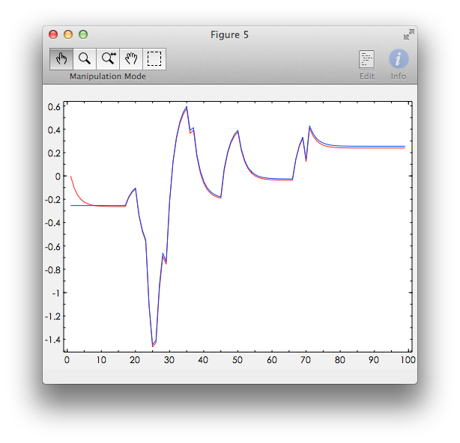

Figure 3.1 Comparison between the responses of estimated model and real model

We can see from the result, at first these two curves have a bigger error, and then they got almost the same, the error is very small.